Chapter 10, Solution 3.

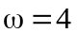
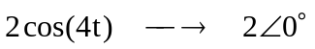
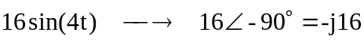
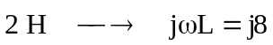
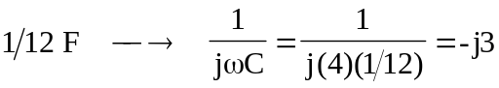

The circuit is shown below.
j8 
1 
6 
-j3 
4 
-j16 V
20 A
+
−
V_{o}

Applying nodal analysis,

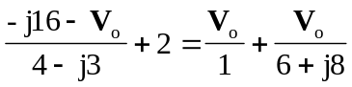

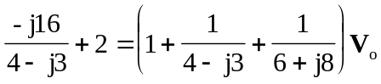

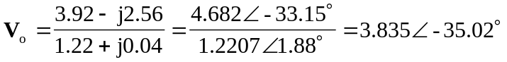

Therefore,
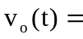 3.835cos(4t – 35.02) V

